# **How Much Does it Cost to Outsource Human Resource**

Human resource management is essential to any business, and outsourcing its functions has become a popular choice for many companies. Outsourcing these services can provide businesses with cost savings, expertise, and more flexibility in managing their workforce. However, the cost of it varies depending on the services required, the business's size, and the outsourcing provider's location.

In this article, we will explore what human resourcing is, why companies should invest in it, and what are the costs associated with outsourcing HR and the factors that affect those costs.

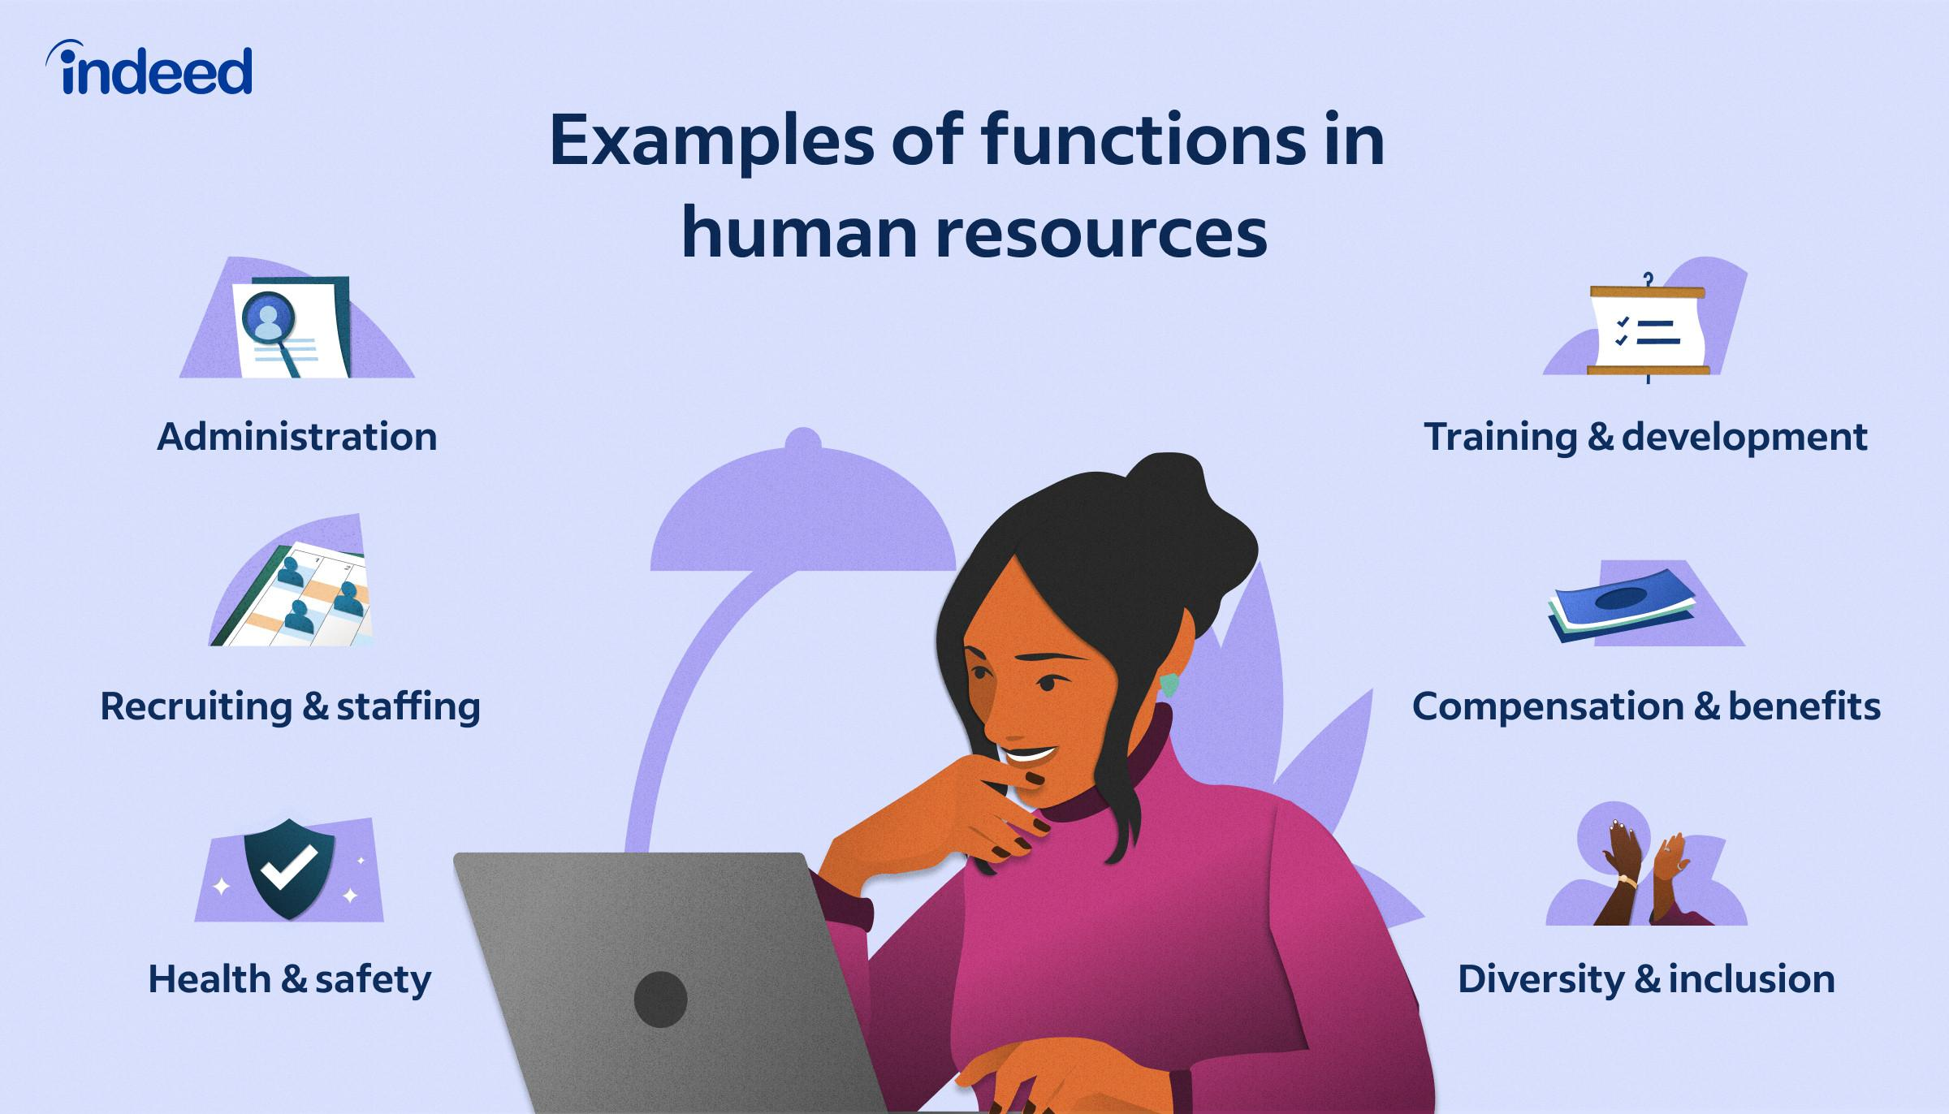

[Source](https://d341ezm4iqaae0.cloudfront.net/assets/2020/04/20215702/HR_Functions01.jpg)

Human Resource (HR) Outsourcing refers to delegating some or all of an organization's human resource management functions to an external service provider. This can include payroll administration, benefits administration, recruitment, employee training and development, employee relations such as diversity & inclusion, health & safety, and compliance management. Companies outsource their HR functions for various reasons, such as reducing costs, increasing efficiency, accessing specialized expertise, and allowing the organization to focus on its core business functions. The outsourcing partner can be a comprehensive HR service provider, a Professional Employer Organization (PEO), or a specialized human resources outsourcing company focusing on specific HR functions

## **Why Should You Outsource HR Services?**

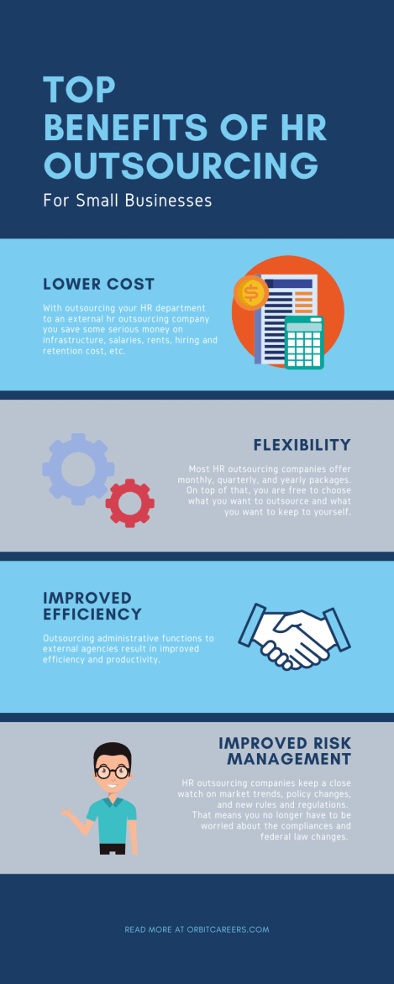

[Source](https://i0.wp.com/orbitcareers.com/wp-content/uploads/2021/04/Blue-Entrepreneur-Personalities-Business-Infographic.png?resize=469%2C1172&ssl=1)

Companies should consider outsourcing human resource services for several strategic reasons that can lead to improved operational efficiency, cost savings, and enhanced competitiveness. The following key factors highlight the rationale behind outsourcing HR functions:

### **Entrance to Expert Proficiency**

Outsourcing allows companies to leverage the skills and knowledge of HR service providers who deeply understand HR best practices, core HR functions and regulations, and emerging trends. This expertise can help organizations navigate the complexities of HR management, ensure compliance with relevant laws, and implement cutting-edge solutions to enhance employee engagement and productivity.

### **Scalability and Flexibility**

As organizations grow, expand, or downsize, their HR needs evolve accordingly. Outsourcing services offer scalability and flexibility, enabling companies to adjust the required support level without hiring or downsizing full-time HR personnel. This adaptability allows organizations to respond swiftly to market dynamics and changing business needs.

### **Cost Savings**

Outsourcing HR functions can result in significant cost savings by reducing overhead expenses related to in-house HR staff, infrastructure, and technology. Moreover, HR outsourcing providers can often leverage economies of scale, delivering services at a lower cost per employee compared to managing the functions in-house. Additionally, organizations can avoid the financial risks associated with non-compliance by relying on the expertise of external HR providers.

### **Enhanced Efficiency and Streamlined Processes**

HR outsourcing providers typically have access to advanced technology and automation tools that can streamline processes, reduce manual tasks, and minimize human error. By leveraging these tools and best practices, organizations can enhance the efficiency of their HR functions, resulting in improved service delivery and more accurate data management.

### **Focus on Core Business Functions**

HR services enable organizations to concentrate their resources on core business functions that drive growth and profitability. By relieving the administrative burden of HR management, companies can allocate more time and energy to strategic initiatives, product development, and customer service, ultimately enhancing their competitive advantage.

### **Mitigation of Legal Risks**

HR outsourcing service providers are well-versed in the latest labor laws, regulations, and compliance requirements. By outsourcing HR functions, organizations can minimize the risk of non-compliance and avoid the associated penalties, fines, and potential reputational damage. This can be particularly beneficial for businesses operating across multiple jurisdictions, where regulations can vary significantly.

### **Continuous Improvement and Innovation**

HR outsourcing firms are continually investing in research, development, and innovation to maintain their competitive edge and provide value-added services to clients. By partnering with an HR service provider, organizations can access the latest tools, methodologies, and thought leadership in the HR domain, ensuring that their HR practices remain up-to-date and aligned with industry standards.

## **What Impacts the Cost of Outsourcing HR Services**

Before diving into specific estimates, it's essential to understand the factors that can impact the cost of HR services. These factors include:

### **Scope and Types of HR Outsourcing**

The Hr outsourcing cost can depend on the range of services your organization requires. Some businesses may choose to outsource specific HR functions such as payroll or benefits administration. In contrast, others may prefer a comprehensive HR solution that covers everything from recruitment to employee relations.

### **Size of the Organization**

The size of your organization will impact the cost of HR services. Larger organizations with more employees will require more extensive HR support, leading to higher costs.

### **Geographic Location**

The cost of HR outsourcing can vary based on the provider's and your business's locations. Differences in labor costs, taxes, and regulations between countries can all impact the cost of outsourcing HR services.

### **Level of Expertise**

The level of expertise required for your organization's HR needs will also affect the cost. A provider offering specialized services or industry-specific expertise may charge higher fees than a more generalist HR outsourcing company.

## **Average HR Outsourcing Prices**

1. **Payroll Outsourcing**Payroll is one of the most commonly outsourced HR functions due to its time-consuming and complex nature of employee payment processing. According to Smart Service, the cost of outsourcing payroll can range from [$20 to $250 per month](https://www.smartservice.com/smart-service-blog/payroll-outsourcing-cost), depending on the services included and the provider's pricing model.
2. **Benefits Administration**Outsourcing benefits administration can help your organization manage employee benefits more efficiently and ensure compliance with relevant regulations. The cost of outsourcing benefits administration typically ranges from [$151 to $182](https://benefitelect.com/wp-content/uploads/2021/06/Cost-Savings-White-Paper-v1.pdf), depending on the complexity of your benefits program and the level of support required.
3. **Recruitment Process Outsourcing (RPO)**Outsourcing your organization's recruitment process can provide access to a broader talent pool by creating high-yield job descriptions in any of your job vacancies and specialized recruitment expertise. RPO costs can vary significantly depending on the provider and the scope of services. According to a report by DesignRush, RPO costs can cost [$800](https://www.designrush.com/agency/hr-outsourcing/trends/hr-outsourcing-costs) per month.
4. **Compliance Management**Global companies must be aware of the severe consequences they face if they do not adhere to labor laws and regulations in various countries. Therefore, outsourcing compliance management is another valuable HR task.  
   HR outsourcing service providers will periodically evaluate and update your policies and regulations to guarantee continued compliance with the rules.  
   The expense for outsourced compliance management is approximately [$12,000](https://www.designrush.com/agency/hr-outsourcing/trends/hr-outsourcing-costs) annually, which is significantly lower than the roughly $200,000 it would cost if managed in-house.
5. **Professional Employer Organizations (PEOs)**A PEO is an HR outsourcing solution that allows your organization to share some of its administrative and regulatory responsibilities with the PEO provider. PEOs typically charge a flat fee based on a percentage of your total payroll, similar to comprehensive HR outsourcing providers. According to the National Association of Professional Employer Organizations (NAPEO), the cost of partnering with a PEO can cost from [$900 to $1,500](https://www.netpeo.com/faqs/how-much-does-it-cost-to-use-a-peo/) annually.
6. **HR Consulting Services**HR consulting services can be a cost-effective solution for organizations that require specialized expertise or support for specific HR projects. The cost of HR consulting services can vary widely depending on the scope of the project, the consultant's expertise, and the duration of the engagement. The average cost of consulting services ranges from [$45 to $1,500 monthly](https://www.usemultiplier.com/blog/hr-outsourcing-prices#:~:text=What%20is%20the%20cost%20to,and%20thus%2C%20the%20wide%20range.).

## **Outsourcing HR Services vs. In-House HR Team - Direct Comparison**

### **Initial Setup Costs**

#### **Outsourcing HR Services**

The initial setup costs for outsourcing HR services are primarily associated with selecting outsourcing companies, negotiating contracts, and integrating their services with existing systems. According to a report by The Balance Small Business, initial costs for HR outsourcing can range from $1,500 to $5,000, depending on the complexity and scope of services required.

#### **In-House HR Team**

Establishing a dedicated HR department involves recruiting, hiring, and onboarding HR professionals, investing in HR technology and infrastructure, such as online HR portals for remote employees, and allocating office space. These costs can vary significantly based on the size of the team, salary expectations, and office space requirements. Glassdoor indicates that the average base salary for an HR generalist in the United States is around [$60,000 per year](https://www.glassdoor.com/Salaries/human-resources-generalist-salary-SRCH_KO0,24.htm), excluding additional expenses such as benefits and office space.

### **Ongoing Expenses**

#### **Outsourcing HR Services**

Ongoing expenses for HR outsourcing companies typically include a flat monthly fee charged by the service provider, often calculated as a percentage of the total payroll or a fixed monthly fee. The National Association of Professional Employer Organizations (NAPEO) estimates that partnering with a PEO can cost between 2% and 12% of an organization's total payroll, contingent on the level of services provided.

#### **In-House HR Team**

Ongoing expenses for an in-house HR team encompass salaries, benefits, office space, equipment, and software subscriptions. These costs can be substantial and may be subject to annual increases. Additionally, investments in employee development and training investments are crucial to maintaining an effective in-house HR team.

### **Total Cost of Ownership**

#### **Outsourcing HR Services**

The total cost of ownership for outsourcing HR services encompasses both initial setup costs and ongoing expenses. Factors such as scalability, access to specialized expertise, and potential cost savings linked to outsourcing HR functions should be considered. Outsourcing HR can sometimes lead to considerable cost savings compared to maintaining an in-house team.

#### **In-House HR Team**

The total cost of ownership for an in-house HR team includes expenses related to hiring, training, and retaining HR professionals, as well as investments in infrastructure, software, and office space. While these costs can be high, an in-house HR team can offer advantages such as greater control over HR processes and more direct interaction with employees.

## **Choosing the Right Human Resource Provider**

Now that we've gathered all the costs to outsource HR services, how would you know which provider best fits your brand?

Before proceeding, we highly encourage you to check out [The New Workforce](https://thenewworkforce.com/). They provide well-equipped talents specializing in human resources organization, HR operations, online marketing, IT support, customer services, and many more!

When selecting the right human resource (HR) provider, companies should consider several factors to ensure the partnership aligns with their business objectives, culture, and requirements. Here are some critical factors to consider:

### **Range of Services Offered**

Determine which HR functions you want to outsource, may it be all your HR functions or just core HR activities such as payroll, benefits administration, recruitment, or training and development. The chosen HR provider should offer comprehensive services tailored to your specific needs.

### **Scalability**

As your organization expands and evolves, the HR provider you choose must have the capacity to adapt their services accordingly to address your shifting requirements, tailor service agreements to your specific needs, and cater to an increasing workforce size. A scalable HR provider will not only ensure that your business's human resources functions are effectively managed throughout its growth stages but will also offer the flexibility to adjust its offerings in response to fluctuations in demand or the emergence of new industry trends and challenges. In this way, you can maintain an efficient HR operation that supports your business's ongoing success and development.

### **Compliance and Risk Management**

Ensure the HR provider has a strong track record of maintaining compliance with relevant labor laws, tax filings, and other regulations and mitigating potential risks associated with HR processes.

### **Cost and Pricing Structure**

Compare various HR providers' costs and pricing structures to determine which offers the best value for your investment. This includes considering initial setup costs, ongoing fees, and additional expenses related to the services provided.

### **Reputation and Client References**

Conduct thorough research on the provider's reputation, read reviews, and request client references to gather insights on the provider's performance and the quality of their services.

Evaluating these factors carefully will help you choose the right HR provider for your organization, ultimately ensuring a successful and mutually beneficial partnership.

## 

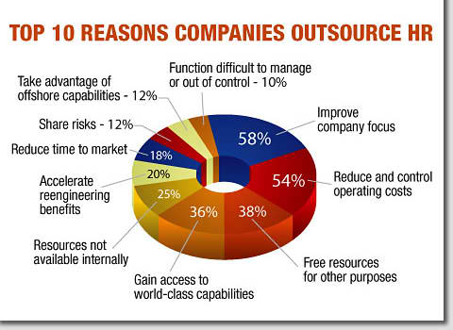

[Source](http://bridge-mc.com/hro_clip_image.jpg)

Outsourcing human resources can be a cost-effective and efficient solution for organizations of all sizes. By understanding the factors that impact HR outsourcing costs and reviewing the specific estimates provided, businesses can make informed decisions about whether outsourcing HR is the right choice for them. Additionally, the potential benefits and cost savings associated with outsourcing HR should not be overlooked, as they can significantly outweigh the costs and contribute to your organization's growth and success.